MAKERERE UNIVERSITY

COLLEGE OF COMPUTING AND INFORMATION SCIENCES

DEPARTMENT OF NETWORKS

BACHELOR OF SCIENCE IN SOFTWARE ENGINEERING (YEAR 2)

RECESS TERM 2 (BSE 2301)

SYSTEM DESIGN DOCUMENT FOR:

STAR WARS MOVIE SCRIPTS ANALYSIS PROJECT

GROUP ONE

PROJECT MEMBERS:

|  |  |  |  |
| --- | --- | --- | --- |
| S/NO. | NAME | REGISTRATION NO. | STUDENT NO. |
| 1 | ONGOM DANIEL | 16/U/18975 | 216020552 |
| 2 | NABWIRE BABRA KILO | 16/U/8255/PS | 216012375 |
| 3 | NANYANZI VICTO | 16/U/9914/PS | 216012525 |
| 4 | KABENI EMMANUEL | 16/U/20449 | 216022248 |
| 5 | THAKKAR BRINDA | 16/X/2271/PS | 216002450 |

PROJECT LEADER: ONGOM DANIEL

SUPERVISOR: NOAH KANGE

SUBMITTED IN PARTIAL FULFILLMENT OF THE REQUIREMENTS FOR THE

SOFTWARE ENGINEERING RECESS PROJECT BSE 2301

3RD JULY 2018

GROUP ONE

**Star Wars movie scripts Analysis Software Project**

Software Design Document

**Lab Section**: College of Computing and Information Sciences, Software Engineering **Workstation**: Makerere University.

Contents

1. INTRODUCTION 1

1.1 PURPOSE 1

1.2 SCOPE 1

1.3 OVERVIEW 2

1.4 REFERENCE MATERIAL 2

1.5 DEFINITIONS AND ACRONYMS 2

2. SYSTEM OVERVIEW 4

3. SYSTEM ARCHITECTURE 5

3.1 ARCHITECTURAL DESIGN 5

3.2 DECOMPOSITION DESCRIPTION 5

3.3 DESIGN RATIONALE 10

4. DATA DESIGN 11

4.1 Data Description 11

4.2 Data Dictionary 11

5. COMPONENT DESIGN 12

6. HUMAN INTERFACE DESIGN 14

6.1 OVERVIEW OF USER INTERFACE 14

6.2 SCREEN IMAGES 15

6.3 SCREEN OBJECTS AND ACTIONS 16

7. REQUIREMENTS MATRIX 16

8. APPENDICES 17

8.1 GLOSSARY 17

# INTRODUCTION

## PURPOSE

This software design document describes the architecture and the system design of the Star Wars movie scripts Analysis software (SWAS) system version 1.0 for analyzing and visualizing raw text data, majorly, movie scripts and in this case, Star Wars movie scripts.

## SCOPE

This document describes the implementation details of the SWAS. The Software will analyze and visualize text data to depict the writer’s intended motive as well as the insights in the data. It’s based in R programming language installed on a computer with the Shiny packages and other relevant packages. R requires RStudio, a free and open source integrated development environment and must be installed as soon as R is already installed.

The objective of the system is to provide a graphical visual and clear understanding of the Star Wars scripts that will assist Star Wars movie writer and other writers in making strategic and proper decisions when planning for the next movie.

The goals of the system are:

* To depict what the movie is all about, and in this case, we are majorly concerned with the Star Wars movie scripts.
* To understand what movie writers are always trying to communicate in different movies, for instance Star Wars movie.
* To motivate movie writers in coming out with new ideas inform of a different movie.
* To analyze different type of text data, not necessarily movie scripts only.

## OVERVIEW

This document is consisting of eight sections that explain its use to the user.

The **Introduction** defines the system’s objective and the summary of the system functionality so as to give the reader a good understanding of the system goals.

The **System Overview** explains to the reader the general system functionality and its design.

The **System Architecture** has the detailed view of the different conceptual requirements for setting up the system in terms of hardware and software.

The **Data Design** defines the data storage techniques and the format of the data for each of the stored data files.

The **Component Design** describes how the different components of the system interact to satisfy the user needs.

The **Human machine interface** explains to the reader the needed skills of the system’s interface in order to be able to interact freely with the system.

The **Requirements matrix** shows the system components that satisfy each of the functional requirements from the SRS document.

**Appendices** contains the glossary where all the key terms used in this document are defined

## REFERENCE MATERIAL

Books: [1] Gary B. Shelly System Analysis and Design 9th Edition 20 Channel Centre Street Boston, MA 02210 USA Nicole Pinard 2012

Links: [1] http://www.cs.concordia.ca/~ormanj/comp354/2003/project/ieee-SDD.pdf

## DEFINITIONS AND ACRONYMS

***Movie Scripts***: This is the text in question to be analyzed and visualized.

***SWAS***: Star Wars movie scripts Analysis Software, is the system that’s yet to be developed.

***Writers:*** These are people who are creative in their thinking and compose different kinds of articles, for instance movie scripts.

# SYSTEM OVERVIEW

Due to inconsistency in most of text data, The SWAS system has been developed with an aim of analyzing and visualizing raw text data using the various statistical tools of analysis, visualization and prediction to assist in planning and decision making. The **system context diagram** below shows the system’s functionalities.

CONTEXT DIAGRAM FOR STAR WARS MOVIE SCRIPTS ANALYSIS

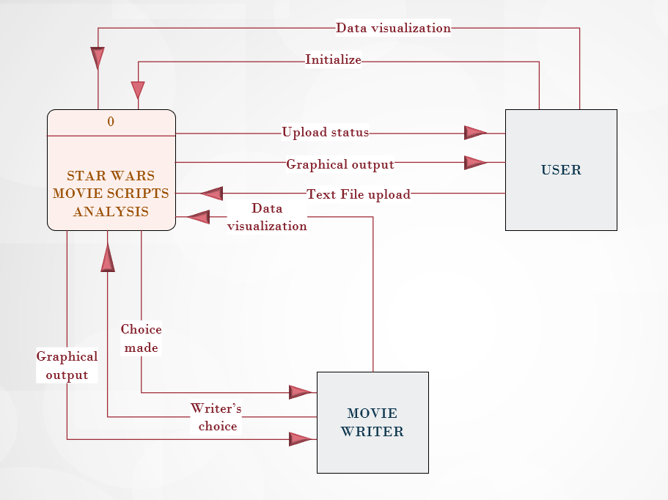

Figure 2.01: System Context Diagram

# SYSTEM ARCHITECTURE

## ARCHITECTURAL DESIGN

The diagrams below show a general understanding of how the individual systems model and how they are working together.

CONCEPTUAL DIAGRAM FOR STAR WARS MOVIE SCRIPTS ANALYSIS

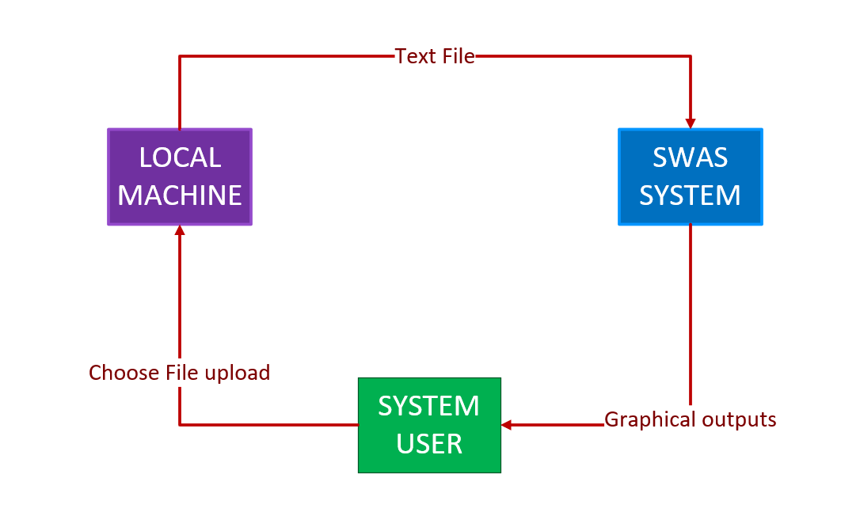

*Figure 3.1.1: Conceptual Diagram for SWAS*

## DECOMPOSITION DESCRIPTION

The system functionality has been broken down and is represented as a functional decomposition diagram and data flow diagrams. Below is the functional decomposition diagram and the corresponding data flow diagrams.

FUNCTIONAL DECOMPOSITION DIAGRAM FOR STAR WARS MOVIE SCRIPTS ANALYSIS

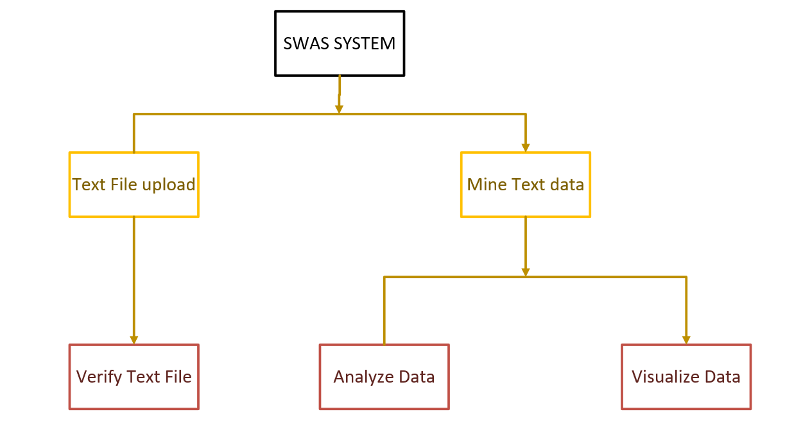

*Figure 3.2.1: Functional Decomposition Diagram*

DIAGRAM 0 DATA FLOW DIAGRAM FOR STAR WARS MOVIE SCRIPTS ANALYSIS

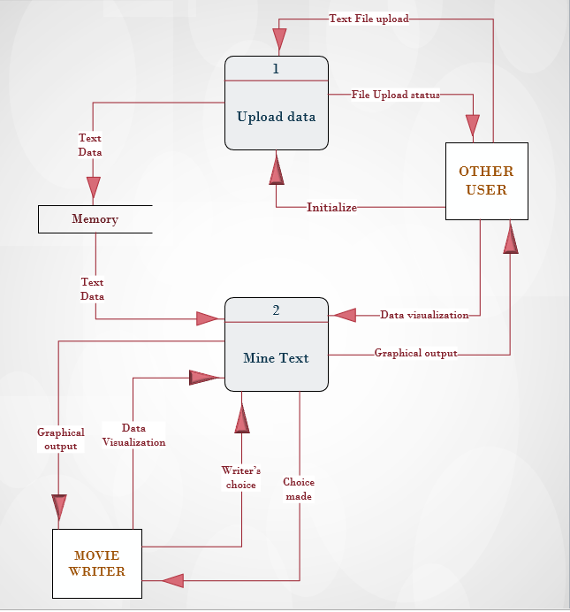

*Figure 3.2.2: Diagram 0 Data Flow Diagram*

DIAGRAM 1 DATA FLOW DIAGRAM FOR STAR WARS MOVIE SCRIPTS ANALYSIS

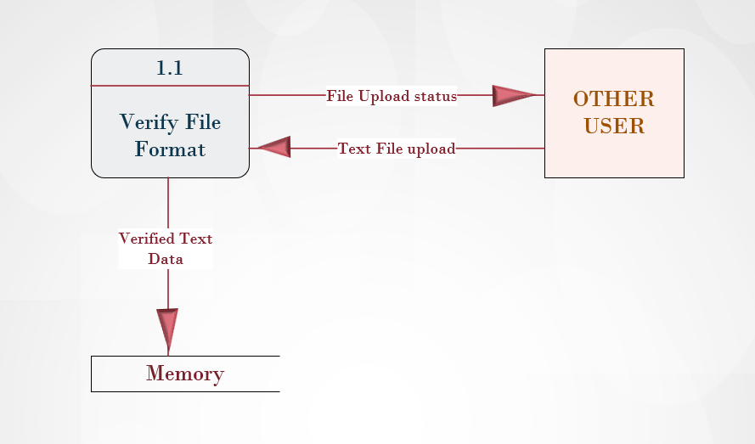

*Figure 3.2.3:* ***Diagram 1*** *Data Flow Diagram for process* ***1***

DIAGRAM 2 DATA FLOW DIAGRAM FOR STAR WARS MOVIE SCRIPTS ANALYSIS

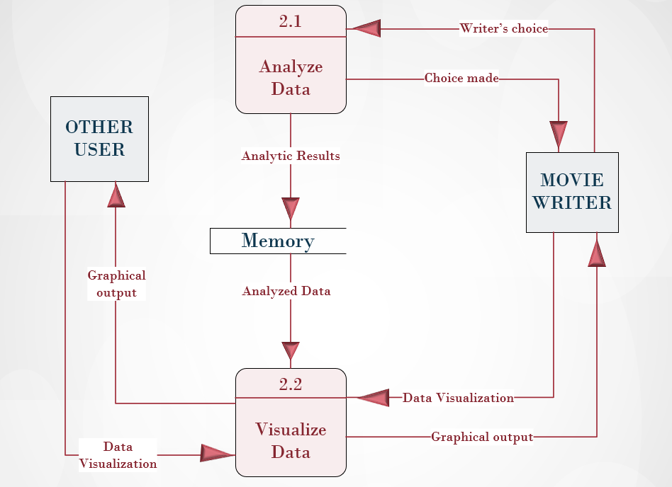

*Figure 3.2.4:* ***Diagram 2*** *Data Flow Diagram for process* ***2***

DIAGRAM 2.2 DATA FLOW DIAGRAM FOR STAR WARS MOVIE SCRIPTS ANALYSIS

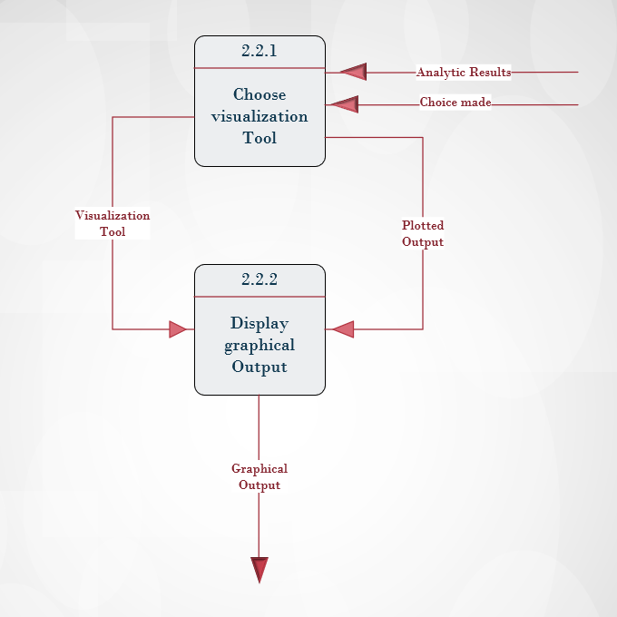

*Figure 3.2.5:* ***Diagram 2.2*** *Data Flow Diagram for process* ***2.2***

## DESIGN RATIONALE

The chosen architecture in 3.1 is good for use in local machine, and it is cheaper to construct.

# DATA DESIGN

## Data Description

The system will not have any database but the user will upload the file (For this project, we are using movie scripts for Star Wars movie) having a data format explained in section 4.2. This file will be uploaded for every user session and will only be stored on the user’s local machine in case he or she wants to.

## Data Dictionary

The table below shows the expected contents of uploaded file in the data store. In this case, we are dealing with movie scripts, thus the content is basically the movie’s characters and their dialogue.

|  |  |  |
| --- | --- | --- |
| **COLUMNS** | **DESCRIPTION** | **DATA TYPE** |
| Characters | This column specifies the name of each character in Star Wars movie. | Text |
| Dialogue | This column contains the conversation between the characters in Star Wars movie. | Text |

Table 1: Data Dictionary

# COMPONENT DESIGN

###### Module 1: Validate data file

The uploaded file must match the file template which is described in section 4.2. When a user uploads a file, it will be checked to ensure that it matches the template. If it doesn't exactly match the template, it will be rejected and the user will be notified and prompted upload another file. This module will be executed for every session of a user.

FLOW CHART DIAGRAM FOR STAR WARS MOVIE SCRIPTS ANALYSIS

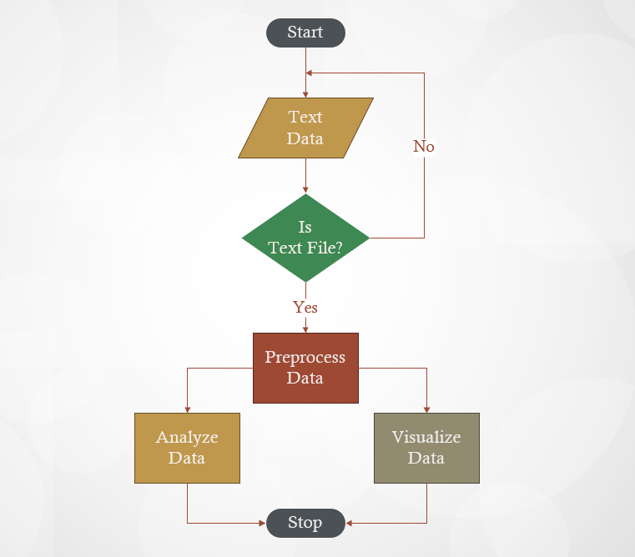

*Figure 5.0.1: Flow Chart Diagram for module 1*

Module Inputs:

* Text data file

Module outputs:

* File Validation Result

###### Module 2: Text Analytics

This module is the core part of the system and will be called frequently and its results will depend on the user commands, for instance when text data is read or uploaded into the system, and it has been verified by model 1. The user will choose which parameters to be analyzed and how they should be analyzed using the graphical interface.

Module inputs:

* User selections/choices
* Text data file

Module outputs:

* Analysis results
* Textual reports

###### Module 3: Graphical Representation of results

The analytical results from module 2 will be presented in a graphical view based on the user selections. A number of graphical features including but not limited to word cloud, bar graphs, histograms will be used by this module to display data to the user. The user will select the tool they wish to use to view the results.

Module inputs:

* User selections/choices
* Analysis results

Module outputs:

* Graphs

# HUMAN INTERFACE DESIGN

## OVERVIEW OF USER INTERFACE

###### Interface Architecture

This system will be standalone in that, it won’t interface with the web since it will be run on a local machine and will interface with it (local machine) as described in the architecture diagram below.

INTERFACE ARCHITECTURE DIAGRAM FOR STAR WARS MOVIE SCRIPTS ANALYSIS

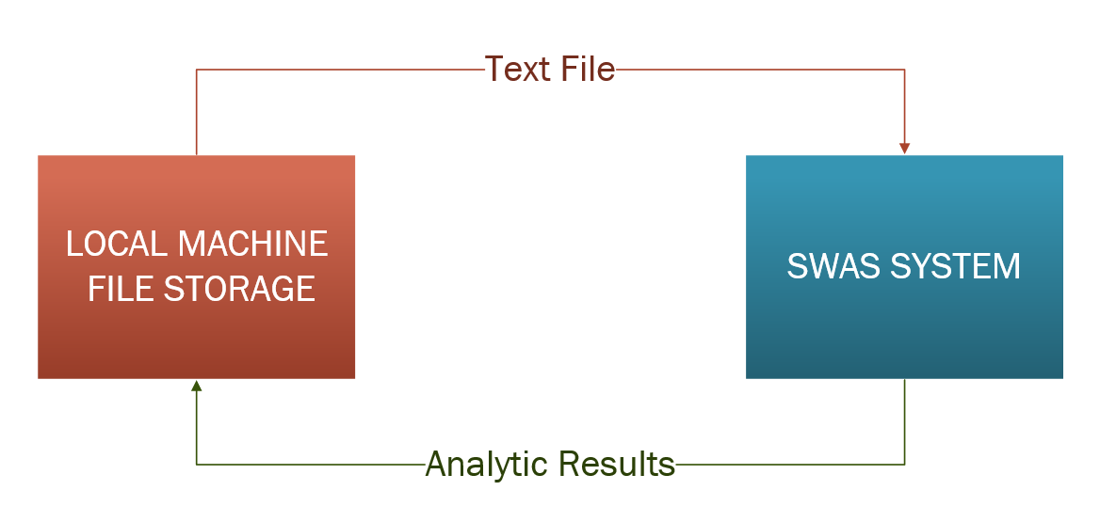

*Figure 6.1.1: Interface Architecture Diagram*

###### Interface Detailed Design

The system users will be required to have basic computer literacy which will be an added advantage to using the SWAS system. On attempt to access the system, the user will be responded to with the graphical user interface of SWAS as of Figure 6.02. Here, the user will be having different choices inform of clickable buttons such as upload file, visualize the data, or analyze the processed data. Upon choosing any of the options, the user will be redirected to a new interface corresponding to the choice made. Thereafter the system will then respond back to the user with the desired results.

## SCREEN IMAGES

SWAS graphical user interface view.



*Figure 6.2.1: SWAS screen image*

## SCREEN OBJECTS AND ACTIONS

The screen image figure 6.0.2 will have a provision for upload text data, visualizing data, and also analyzing data.

# REQUIREMENTS MATRIX

Requirements Table

|  |  |
| --- | --- |
| **FUNCTIONALITY REQUIREMENTS** | **REFERENCE SECTION IN SRS** |
| External Interface Requirements | 3 |
| System features | 5 |
| Other nonfunctional requirements | 6 |

Table 2: Requirements Table

# APPENDICES

## GLOSSARY

|  |  |
| --- | --- |
| **TERM** | **DEFINITION** |
| Text Data file | A file containing the text data to be analyzed by the system. |
| Graphical output | This is output data that is visualized on various charts and graphs. |
| Database | A data store consisting of relational tables. It is used for data storage. |
| Data Flow Diagram | A data flow diagram (DFD) is a graphical representation of the "flow" of data through an information system, modeling its process aspects. |
| Functional Decomposition Diagram | A *decomposition diagram* shows a high-level *function*, process, organization, data subject area, or other type of object broken down into lower level, more detailed components. |
| Module | This is a part of a computer or computer program that does a particular job. |
| R Shiny package | An R package for supporting web-based data analysis systems. |
| Flow Chart | A chart showing steps to be followed when accomplishing a task. |
| User Interface | The part of the software a user interacts with. |

Table **3**: Glossary